Strategic IT Governance 2.0
Maturity Assessment
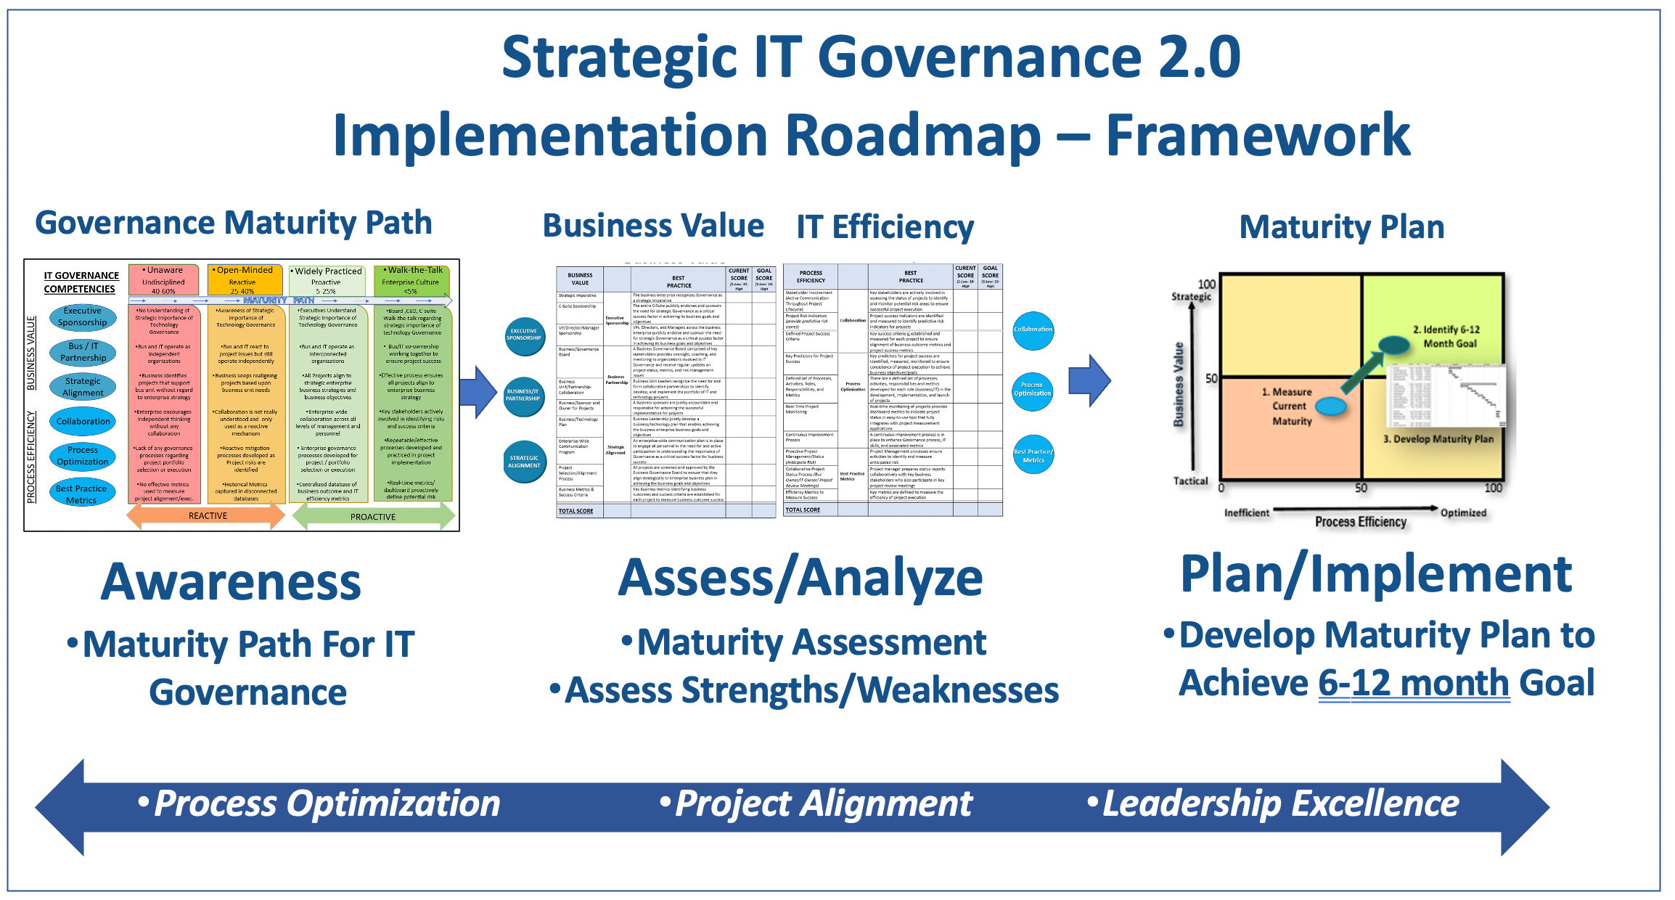

Strategic IT Governance 2.0
Maturity Assessment

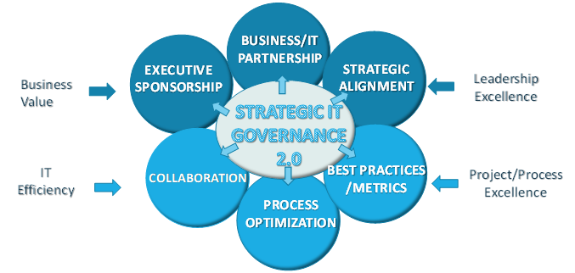

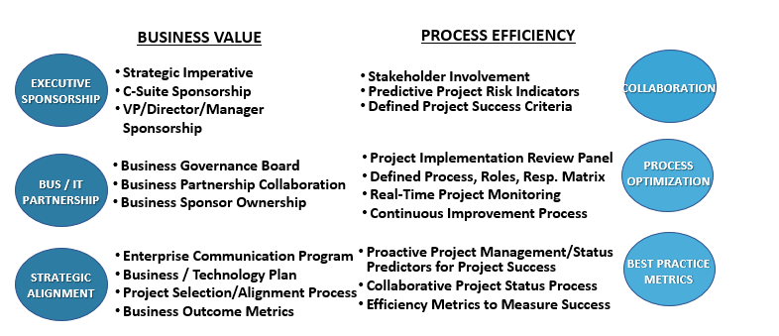

Strategic IT Governance 2.0 Maturity Assessment- Business Value

COMPETENCY | BUSINESS VALUE PROCESS | BEST  PRACTICE | CURRENT  SCORE  (1-Low: 10-High | GOAL  SCORE  (1-Low: 10-High
Executive Sponsorship | Strategic Imperative | The business enterprise recognizes Governance as a strategic imperative
 | C-Suite Sponsorship | The entire C-Suite publicly endorses and sponsors the need for strategic Governance as a critical success factor in achieving its business goals and objectives
 | VP/Director/Mgr Sponsorship | VPs, Directors, Managers across the business enterprise publicly endorse, sponsor, and participate in the need for strategic Governance as a critical success factor in achieving its business goals and objectives
Business  Partnership | Business  Governance Board | A Business Governance Board comprised of key stakeholders provides oversight, coaching, and mentoring to organizations involved in IT Governance and receive regular updates on project status, metrics, and risk management issues
 | Business Unit/Partnership-Collaboration | Business Unit Leaders recognize the need for and form collaborative partnerships to identify, develop, and implement the portfolio of IT and technology projects
 | Business/IT Sponsor and Owner for Projects | Business sponsors/IT are jointly accountable and responsible for achieving the successful implementation of projects
Strategic  Alignment | Business/Tech. Plan | Business Leadership jointly develop a business/technology plan that enables achieving the business enterprise business goals and objectives
 | Enterprise-Wide Communication Program | An enterprise-wide communication plan is in place to engage all personnel in the need for and active participation in understanding the importance of Governance as a critical success factor for business success
 | Project Selection/ Alignment Process | All projects are screened and approved by the Business Governance Board to ensure that they align strategically to enterprise business plan in achieving the business goals and objectives
 | Business Metrics & Success Criteria | Key business metrics identifying business outcomes and success criteria established for each project to measure business outcome success
 |  | TOTALS
Strategic IT Governance 2.0 Maturity Assessment – IT Efficiency
COMPETENCY | IT  EFFICIENCY PROCESS | BEST  PRACTICE | CURRENT  SCORE  (1-Low: 10-High | GOAL  SCORE  (1-Low: 10-High
Collaboration | Stakeholder Involvement (Active Communication Throughout Project Lifecycle) | Key stakeholders are actively involved in assessing the status of projects to identify and monitor potential risk areas to ensure successful project execution
 | Project Risk Indicators (provide predictive risk scores) | Project success indicators are identified and measured to determine predictive risk indicators for projects
 | Defined Project Success Criteria | Key success criteria are established and measured for each project to ensure alignment of business outcome metrics and project success metrics
Process  Optimization | Project Implementation Review Panel | Project Implementation Review Panel established to oversees project status (schedule, financials, issues, mitigation plans) to reduce project risk
 | Defined set of Processes, Activities, Roles, Responsibility and Metrics | There are a defined set of processes, activities, responsibilities and metrics developed for each role (business/IT) in the development, implementation, and launch of projects
 | Real-Time Project Monitoring | Real-time monitoring of projects provides dashboard metrics to indicate project status in easy-to-use tool that fully integrates with project measurement applications
 | Continuous Improvement Process | A continuous improvement process is in place to enhance Governance process, IT skills, and associated metrics
Best Practice Metrics  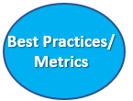 | Proactive Project Mgmnt/Status (Anticipate Risk) | Project Management processes ensure activities to identify and measure anticipated risk
 | Collaborative Project Status Process  (Bus Owner/IT Owner/Project Review Meetings) | Project manager prepares status reports collaboratively with key business stakeholders who also participate in key project review meetings
 | Efficiency Metrics to Measure Success | Key metrics are defined to measure the efficiency of project execution
 |  | TOTALS

Strategic IT Governance 2.0 Maturity Assessment – Summary Table
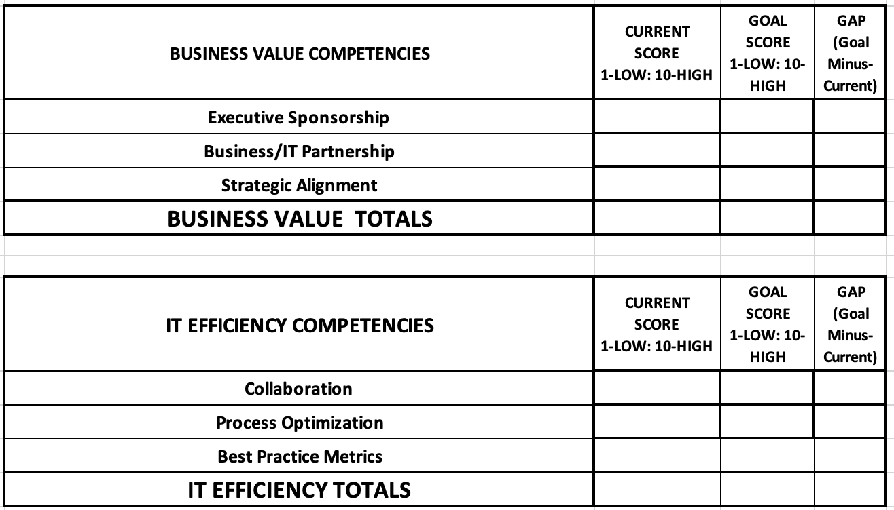
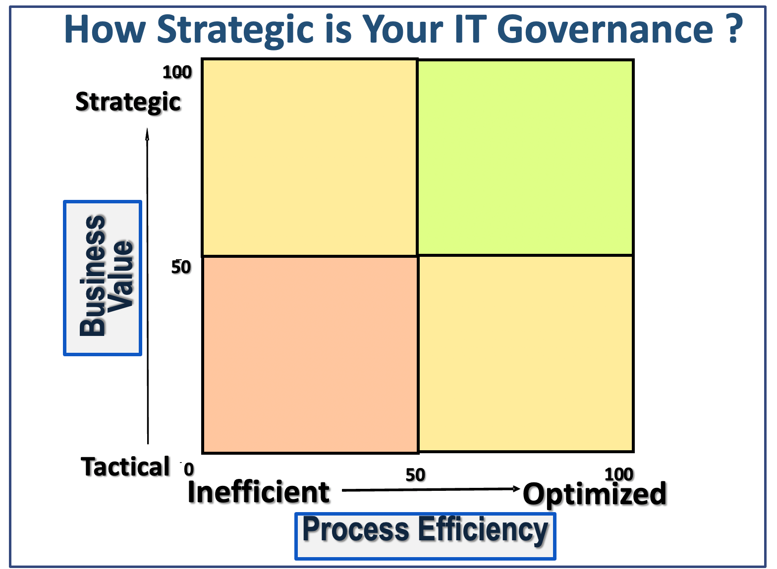
SCORING RATIONAL
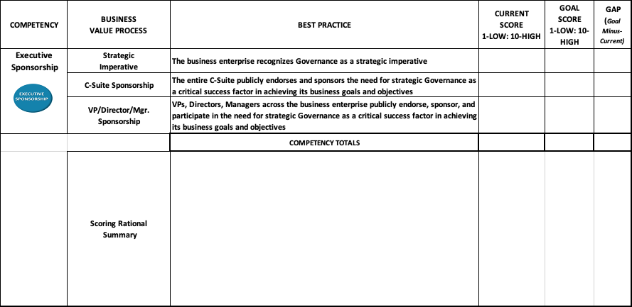

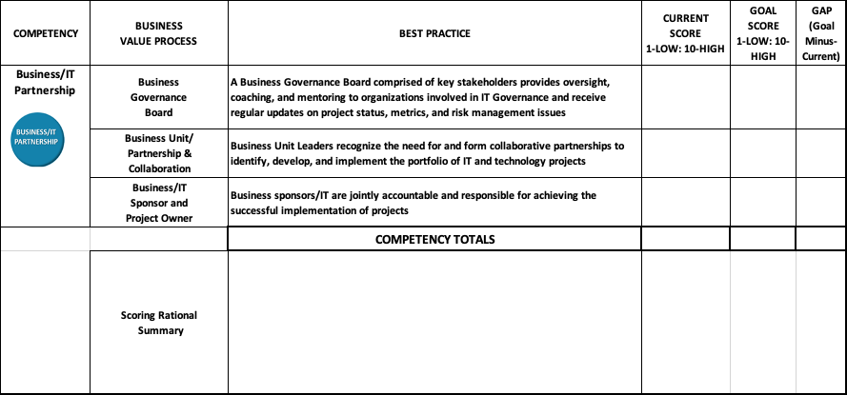
SCORING RATIONAL
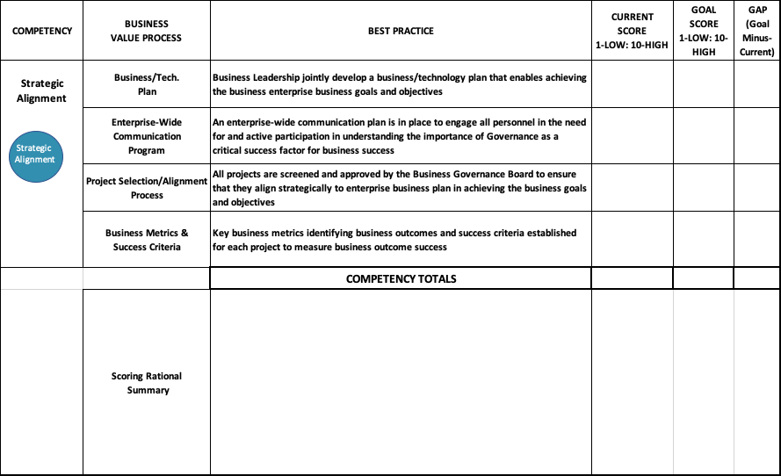
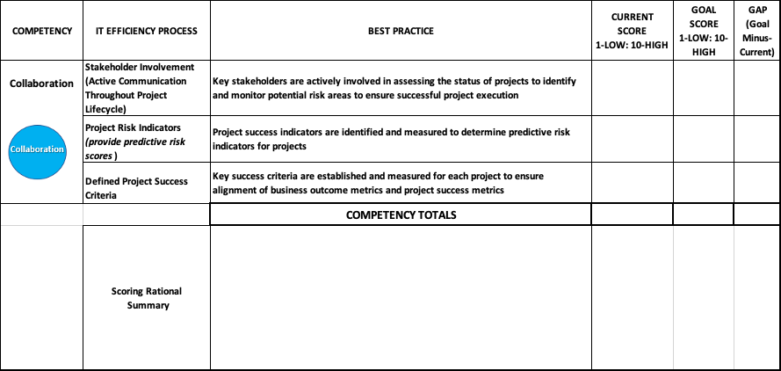

SCORING RATIONALS

